

**SUMMER INTERNHSIP**

PROJECT REPORT ON

# **HAL Parts Defect Detection System**

# **Under the guidance of**

# **Mr. Mahesh Chandra Srivastava**

(Senior Manager (IT))

# **Submitted to** Hindustan Aeronautics Limited (HAL) TAD Kanpur

|  |  |
| --- | --- |
| **SUPERVSED BY:**  **Mr. Rajveer Singh**  **[DGM (IT & Lean)]** | **PRESENTED BY:**  **Abhiyanshu Anand**  **Ishaan Tripathi**  **Suryansh Singh** |

**Certificate**

This is to certify that Project entitled “**HAL Parts Defect Detection System**” has been successfully completed and submitted by Abhiyanshu Anand and has fulfilled the requirements of summer training program at Hindustan Aeronautics Limited TAD Kanpur, under our supervision and guidance, during the period of 20th June 2025 to 17th July 2025.

**Guided By: Certified By:**

**Mr. Mahesh Chandra Srivastava Mr. Rajveer Singh**

Senior Manager (IT) DGM (IT and Lean)

HAL TAD Kanpur HAL TAD Kanpur

**Certificate**

This is to certify that Project entitled “**HAL Parts Defect Detection System**” has been successfully completed and submitted by Ishaan Tripathi and has fulfilled the requirements of summer training program at Hindustan Aeronautics Limited TAD Kanpur, under our supervision and guidance, during the period of 25th June 2025 to 21th July 2025.

**Guided By: Certified By:**

**Mr. Mahesh Chandra Srivastava Mr. Rajveer Singh**

Senior Manager (IT) DGM (IT and Lean)

HAL TAD Kanpur HAL TAD Kanpur

**Certificate**

This is to certify that Project entitled “**HAL Parts Defect Detection System**” has been successfully completed and submitted by Suryansh Singh and has fulfilled the requirements of summer training program at Hindustan Aeronautics Limited TAD Kanpur, under our supervision and guidance, during the period of 17th June 2025 to 15th July 2025.

**Guided By: Certified By:**

**Mr. Mahesh Chandra Srivastava Mr. Rajveer Singh**

Senior Manager (IT) DGM (IT and Lean)

HAL TAD Kanpur HAL TAD Kanpur

**Declaration**

I hereby state that the report titled “**HAL Parts Defect Detection System**” has been prepared by me to fulfil the requirements of Summer Training and project work done at Hindustan Aeronautics Limited TAD Kanpur from 20th June 2025 to 17th July 2025, is an outcome of my own efforts and is an original one.

**Abhiyanshu Anand**B.Tech, 6th Semester  
Computer Science and Engineering (AI & ML)  
JSS Academy of Technical Education   
Noida, Uttar Pradesh Pin-201301

**Declaration**

I hereby state that the report titled “**HAL Parts Defect Detection System**” has been prepared by me to fulfil the requirements of Summer Training and project work done at Hindustan Aeronautics Limited TAD Kanpur from 25th June 2025 to 21th July 2025, is an outcome of my own efforts and is an original one.

**Ishaan Tripathi**B.Tech , 4th Semester

Computer Science and Engineering  
Babu Banarasi Das Northern India Institute of Technology  
Lucknow, Uttar Pradesh Pin- 226028

**Declaration**

I hereby state that the report titled “**HAL Parts Defect Detection System**” has been prepared by me to fulfil the requirements of Summer Training and project work done at Hindustan Aeronautics Limited TAD Kanpur from 17th June 2025 to 15th July 2025, is an outcome of my own efforts and is an original one.

# **Suryansh Singh** B.Tech , 6th Semester Computer Science and Engineering Dr Virendra Swarup Group of Institutions Kanpur, Uttar Pradesh, Pin-209862

**Table of Contents**

|  |  |  |
| --- | --- | --- |
| **S No.** | **Title** | **Page No** |
| **1** | **Acknowledgement** | **9** |
| **2** | **List of Abbreviations** | **10** |
| **3** | **Introduction** | **11** |
| **4** | **History of HAL** | **12** |
| **5** | **History of HAL TAD Kanpur** | **14** |
| **6** | **Organisation and Department Structure** | **16** |
| **7** | **Work Assignment and Analysis Scope** | **18** |
| **8** | **Summary** | **24** |
| **9** | **Conclusion** | **25** |
| **10** | **Source Code** | **26** |
| **11** | **Implementation** | **37** |
| **12** | **Recommendations** | **40** |
| **13** | **References** | **42** |

# **Acknowledgment**

I would like to express my sincere gratitude to Hindustan Aeronautics Limited (HAL), Transport Aircraft Division (TAD), Kanpur, for providing me with the opportunity to undertake this internship project focused on the development of a Web-Based Aircraft Parts Requisition Management System.

I am especially thankful to the IT Department at HAL TAD Kanpur for their invaluable support, guidance, and access to internal systems throughout the project. Their mentorship enabled me to gain hands-on experience in enterprise-level software development, database management, and full-stack web technologies.

I am deeply grateful to my project guide, Mr. Mahesh Chandra Srivastava, for his constant encouragement, expert feedback, and technical insights, which were instrumental in the successful completion of this project. I would also like to extend my appreciation to the team members and staff at HAL who actively participated in testing, reviews, and provided constructive suggestions.  
I sincerely thank my academic institution and faculty advisors for their support and for enabling me to undertake this industrial internship as part of my curriculum. The practical experience gained through this project has significantly enhanced my understanding of real-world applications. Finally, I am thankful to my peers, friends, and family for their continuous moral support, patience, and encouragement during the entire course of this project.

**List of Abbreviation**

|  |  |
| --- | --- |
| **Abbreviation** | **Full Form** |
| HAL | Hindustan Aeronautics Limited |
| API | Application Programming Interface |
| SSIM | Structural Similarity Index Measure |
| YOLO | You Only Look Once (Object Detection Model) |
| ORB | Oriented FAST and Rotated BRIEF (Feature Detector) |
| SIFT | Scale-Invariant Feature Transform |
| CSV | Comma-Separated Values |
| LAB | Lightness A B color space |
| BGR | Blue Green Red (OpenCV image color format) |
| GPU | Graphics Processing Unit |
| DeltaE | Delta E (Color Difference Metric) |
| UI | User Interface |
| AI | Artificial Intelligence |
| PT | PyTorch Model File  (file extension `.pt`) |

**Introduction**

The HAL Parts Defect Detection System is an advanced image processing and artificial intelligence-based solution developed for Hindustan Aeronautics Limited (HAL). The primary objective of this system is to assist in the automated detection of defects in aircraft parts and components through image comparison and AI-driven analysis.

Traditionally, defect detection in manufacturing and maintenance processes has been a manual, time-consuming, and error-prone activity. To address these challenges, this project integrates state-of-the-art computer vision techniques such as Structural Similarity Index Measure (SSIM), YOLOv8 object detection, ORB pattern matching, and color variance analysis (Delta E) to accurately and efficiently identify defects such as cracks, dents, scratches, and color inconsistencies.

The system is built using Python, OpenCV, Streamlit, and machine learning libraries to create a user-friendly interface that enables users to upload multi-angle reference and test images for comparison. Additional features such as automatic image alignment, superpoint matching, pattern defect detection, and color defect highlighting ensure high accuracy in defect identification, even when images differ slightly in scale, orientation, or lighting.

This project is specifically tailored to improve quality control processes at HAL by reducing manual inspection time, increasing detection precision, and enabling real-time defect reporting through detailed tables and downloadable CSV reports.

The HAL Parts Defect Detection System represents a significant step toward automated, scalable, and reliable defect detection in the aerospace manufacturing and maintenance industry.

**History of Hindustan Aeronautics Limited (HAL)**

Hindustan Aeronautics Limited (HAL) is India’s largest aerospace and defence company and one of the oldest in the world still in operation under the same name. It has been pivotal to India’s defence preparedness, aircraft development, and aviation ecosystem.

**Foundation and Early Years (1940–1950s)**

* HAL was founded on December 23, 1940, in Bangalore (now Bengaluru) by Walchand Hirachand, in collaboration with the Government of Mysore and the British Government.
* Originally named Hindustan Aircraft Limited, the company started by repairing and overhauling aircraft for the British Royal Air Force during World War II.
* After India’s independence, the Indian government acquired the company in 1947, and it was later merged with Aeronautics India Limited in 1964 to form what is now Hindustan Aeronautics Limited.

**Expansion and Indigenous Development (1960s–1990s)**

* HAL played a significant role in the development of India's first indigenous aircraft, the HF-24 Marut, designed by the German engineer Dr. B . Kurt Tank.
* In the following decades, HAL expanded its capabilities to include the manufacture of MiG series jets under license from the Soviet Union.
* It also manufactured helicopters, trainers, engines, and avionics for the Indian Armed Forces.
* HAL developed indigenous trainers like HPT-32, and continued assembling aircraft such as the Jaguar, Mirage 2000, and Sukhoi Su-30MKI.

**Modernization and Indigenous Programs (2000–2020)**

* HAL became central to India's modern defence manufacturing, developing aircraft such as the Light Combat Aircraft (LCA) Tejas, Advanced Light Helicopter (ALH) Dhruv, and Light Combat Helicopter (LCH).
* Collaborated with DRDO and ISRO for strategic defence and space programs.
* Expanded its R&D centres, divisions, and manufacturing facilities across India.

**Recent Developments (2020–2025)**

* In the past five years, HAL has increased its focus on self-reliance and Make in India initiatives.
* Inducted Tejas Mk1A, began LCH production, and supported advanced jet trainer development.
* HAL launched initiatives for digital transformation, including smart manufacturing and software-based maintenance systems.
* Played a critical role in maintaining operational readiness during border stand-offs and COVID-19 logistics.
* Today, HAL operates more than 20 production units and R&D centres across India, with global collaborations and export strategies.

**History of HAL TAD Kanpur (Transport Aircraft Division)**

The Transport Aircraft Division (TAD) of HAL, located in Chakeri, Kanpur, is one of the most prominent divisions focused on the design, production, overhaul, and upgrade of transport aircraft.

**Establishment and Initial Operations**

* HAL TAD Kanpur was established in 1960 as part of HAL's strategy to decentralize manufacturing operations and address the growing needs of the Indian Air Force for medium transport aircraft.
* The division was initially involved in assembling and supporting Avro 748 aircraft under license from Hawker Siddeley.

**Development and Capabilities (1970s–2000s)**

* Over the decades, HAL Kanpur expanded its infrastructure to support the full-scale manufacturing of aircraft structures, engines, avionics integration, and testing.
* Took over servicing and modification roles for Dornier Do 228, HS 748, and AN-32 aircraft.
* Developed expertise in modernization and life extension of IAF transport aircraft and trainer fleets.

**Strategic Role and Modern Era (2000–2025)**

* HAL TAD Kanpur continues to be the main base for the Do-228 utility aircraft, which serves roles in transport, maritime patrol, and civil operations.
* The division began producing the civil-certified variant of the Do-228, marking HAL’s entry into regional civil aviation manufacturing.
* In the past five years, TAD Kanpur has undertaken digital transformation projects like web-based maintenance tracking, costing systems, and shopfloor digitization.
* Focused on precision manufacturing, digitization of processes, and supporting export orders for utility aircraft.
* The division plays a critical role in HAL’s mission by integrating design, production, and MRO (Maintenance, Repair, Overhaul) capabilities into a single facility for fixed-wing transport aircraft.

**Organization and Departmental Structure**

**Information Technology (IT) Department – HAL TAD Kanpur**

The Information Technology (IT) Department at HAL TAD Kanpur functions as the central nervous system of digital operations, enabling seamless integration across engineering, manufacturing, administrative, and logistics departments. It supports the plant’s mission through technological solutions, software development, network infrastructure, and data management services.

**1. Departmental Overview**

The IT Department is responsible for:

* Managing enterprise-level software systems.
* Designing and maintaining internal applications (such as costing, HR, planning).
* Handling secure data storage, backup, and disaster recovery.
* Providing technical support and digital transformation for operational efficiency.

The department reports to the General Manager (GM) – TAD Kanpur, with interdepartmental collaboration across Production, Planning, Quality Control, and Finance divisions.

**2. Departmental Structure**

The IT team is structured in the following manner:

| Designation | Responsibility |
| --- | --- |
| CoP, Head OF Division | Department head, strategic decision-making, vendor liaison |
| Senior Chief Manager | Supervising development teams, planning new projects |
| Chief Manager | Web-based tools, internal apps, databases |
| Chief Supervisor SMT | Server maintenance, data security, backups |
| Assistant Supervisor | On-site hardware and software troubleshooting |
| Interns / Trainees | Assigned specific modules for development/testing |

**3. Functions and Core Responsibilities**

* Application Development: Building customized tools for TAD operations such as MSR Costing, production dashboards, and shopfloor entry systems.
* Database Management: Maintaining MySQL/MS SQL servers, role-based access, and secure schema structures.
* System Maintenance: Ensuring uninterrupted operations of servers, internet connectivity, and in-house applications.
* Cybersecurity: Applying firewalls, antivirus policies, and user access control to protect sensitive data.
* User Support: Training and resolving system-related issues faced by employees.

**4. Technologies Used**

* Languages & Tools: HTML, CSS, JavaScript, Node.js, MySQL, Express, PHP, .NET (legacy systems)
* Infrastructure: Local LAN/WAN, managed servers, in-house cloud storage, secure terminals
* Software: ERP interfaces, costing software, inventory systems, and web-based portals
* The IT Department is central to HAL’s vision of digitally transforming legacy systems into modern, web-accessible, and integrated solutions. The MSR Costing Web Application is a significant example of this transformation, enhancing efficiency and collaboration across departments.

**Work Assignment**

During the course of the internship/project at Hindustan Aeronautics Limited (HAL), TAD Kanpur, the assigned task focused on developing an automated defect detection system for aircraft parts to improve inspection accuracy and reduce manual intervention. The traditional defect identification process was manual, time-consuming, and prone to human error. The objective of this project was to digitize and automate the defect detection process using computer vision and artificial intelligence (AI) techniques.

## Key Objectives of the Assignment

* Develop an interactive, web-based defect detection system using Streamlit.
* Integrate image comparison techniques such as Structural Similarity Index Measure (SSIM) for precise defect identification.
* Implement YOLOv8 object detection to identify complex defects using AI.
* Enable automatic image alignment to handle varying scales, orientations, and perspectives.
* Incorporate additional detection modules for color defects (Delta E analysis) and pattern defects (ORB matching).
* Ensure compatibility with multi-angle reference and test images.
* Provide real-time visual defect highlighting and generate detailed, downloadable defect reports in CSV format.
* Maintain data accuracy, process transparency, and system responsiveness.

## User Roles & Responsibilities

### Shop Floor Inspector (Primary User)

* Uploads reference images and test images of aircraft parts for defect analysis.
* Selects detection preferences such as color defect detection, pattern defect detection, and YOLO model-based detection.
* Reviews AI-generated defect images and detailed defect tables.
* Downloads defect reports in CSV format for record-keeping and quality assurance.

### Quality Control (QC) User

* Validates AI-generated defect results.
* Reviews the side-by-side comparison of reference and defective parts.
* Assesses color deviation, pattern mismatches, and structural differences.
* Decides whether the part is acceptable or requires further investigation.

### System Administrator

* Manages system settings including detection sensitivity thresholds, defect classification criteria, and model uploads.
* Monitors the image processing workflows and ensures data storage consistency.
* Updates YOLOv8 model files when improved datasets are available.

## System Workflow (Real-World Simulation)

### 1. Image Upload

The Shop Floor Inspector uploads multi-angle reference images and multi-angle test images for the same part. Optional YOLOv8 AI models can also be uploaded to enhance defect detection.

### 2. Image Pre-Processing & Alignment

The system automatically aligns reference and test images using SuperPoint, SIFT, ORB, and Template Matching techniques to ensure accurate comparisons despite image rotations or scale differences.

### 3. AI-Based Defect Detection

* The system performs SSIM-based image comparison to detect structural defects like cracks, dents, and scratches.
* YOLOv8 object detection is applied for advanced AI-based defect classification.
* Color difference analysis (Delta E) is used to highlight color mismatches.
* Pattern defect detection ensures that component patterns match across the compared images.

### 4. Defect Reporting

The system visually highlights all detected defects on the test image and generates detailed defect tables showing defect type, location, size, and confidence levels. Reports can be downloaded in CSV format.

### 5. Quality Control Review

The QC User cross-verifies the detected defects, reviews image differences, and ensures defect classification is correct before passing the final decision.

### 6. Audit & Tracking

All inspections, defect findings, image processing logs, and report downloads are timestamped and recorded for transparency, traceability, and future audits.

**Scope of Work Analysis**

The scope of the HAL Parts Defect Detection System project was structured around the following key phases:

## 1. Requirement Gathering

* Understanding the manual defect detection processes currently followed for aircraft parts inspection.
* Identifying the primary user roles and their system requirements:
  + Shop Floor Inspector (image uploader and defect requester)
  + Quality Control (QC) User (defect reviewer and validator)
  + System Administrator (threshold manager and model updater)
* Analyzing image comparison standards, color variation tolerances, and pattern inspection requirements followed in the manufacturing and maintenance workflow.
* Evaluating the necessity for multi-angle image support, automatic alignment, and real-time defect reporting.

## 2. System Design & UI Planning

* Designing a streamlined and user-friendly web interface using Streamlit for all users.
* Creating detection control panels to adjust sensitivity thresholds and toggle detection methods (SSIM, YOLO, color defects, pattern defects).
* Implementing visual dashboards to display:
  + Side-by-side image comparisons
  + Defect detection overlays
  + Color variation maps and pattern match visualizations
* Building a responsive system layout compatible with shop floor desktops and laptops.
* Defining file validation rules for uploaded reference and test images.

## 3. Backend Development & Image Processing Integration

* Building a robust backend using OpenCV and Python to handle image processing tasks.
* Integrating advanced defect detection algorithms:
  + SSIM-based structural comparison
  + YOLOv8 object detection model
  + Color variance detection using Delta E
  + Pattern defect detection using ORB and SIFT
* Enabling automatic image alignment through SuperPoint, ORB, and Template Matching techniques.
* Structuring the system to support multi-reference and multi-test workflows with defect summary reports.

## 4. Functional Implementation

* Shop Floor Inspector Module:
  + Upload reference and test images.
  + Adjust defect detection parameters.
  + Trigger AI-based defect detection.
  + Review image comparisons and defect tables.
  + Download defect reports (CSV).
* Quality Control (QC) User Module:
  + Validate detected defects across structural, color, and pattern categories.
  + Cross-verify results before final approval.
  + Provide feedback or request re-analysis if necessary.
* System Administrator Module:
  + Configure detection thresholds.
  + Upload updated YOLOv8 models for improved accuracy.

## 5. Testing and Optimization

* Conducting iterative testing with multiple reference and test images under different lighting, angles, and defect conditions.
* Validating:
  + Image alignment accuracy.
  + Defect classification precision.
  + Multi-angle defect detection workflows.
* Performing User Acceptance Testing (UAT) with representatives from the inspection and QC teams.
* Incorporating user feedback to improve detection sensitivity, interface usability, and processing speed.

## 6. Deployment and Integration Readiness

* Ensuring cross-browser compatibility for the Streamlit web app on facility desktops and laptops.
* Preparing detailed system documentation, including user manuals, process flows, and detection guidelines.
* Training end-users on defect detection workflows and system operation.
* Planning for future integration with HAL’s existing ERP and inventory management systems to enable automated part tagging and defect logging.

**Summary**

This project is a web-based application developed to automate and enhance the defect detection process for aircraft manufacturing and maintenance parts at Hindustan Aeronautics Limited (HAL), TAD Kanpur. The system replaces manual inspection workflows with a streamlined, AI-powered platform that improves accuracy, reduces inspection time, and provides real-time defect analysis.

The system allows the Shop Floor Inspector to initiate the process by uploading multi-angle reference and test images of aircraft parts. The user can enable or disable various defect detection methods such as structural defect detection (SSIM), AI-based detection (YOLOv8), color defect analysis (Delta E), and pattern defect detection (ORB). The system processes these images to automatically identify and highlight potential defects including cracks, dents, scratches, and color mismatches.

The Quality Control (QC) User reviews the AI-generated defect reports, verifies the highlighted defects, and ensures that the results align with HAL’s quality standards. The QC User can approve the inspection, recommend re-analysis, or flag the part for further manual review.

The System Administrator manages system thresholds, uploads updated AI models, and ensures the backend processing pipeline operates correctly. The administrator also oversees system parameters to maintain high detection accuracy.

The application is developed using Python, Streamlit, OpenCV, and machine learning libraries for real-time image processing and defect detection. It supports interactive dashboards, side-by-side image comparisons, defect overlays, and downloadable CSV reports to facilitate collaboration between inspection and QC teams.

This system significantly improves traceability, transparency, and inspection speed while reducing manual errors. It is designed to be fully scalable, with the potential for future integration into HAL’s broader Enterprise Resource Planning (ERP) and inventory management systems to automate part tracking and defect history logging.

**Conclusion**

The main objectives of the **HAL Parts Defect Detection System** project were:

* **Portability** – Develop a web-based platform that allows inspectors and QC personnel to access the defect detection system from multiple shop floor terminals and devices using standard web browsers, providing flexibility and ease of use.
* **Responsiveness** – Ensure the system delivers fast image processing, real-time defect detection, and smooth user interactions to support immediate decision-making by inspection and quality teams.
* **Role-based Access Control** – Implement clearly defined user roles to control access for:
  + **Shop Floor Inspector** – Uploads images and initiates defect detection.
  + **Quality Control (QC) User** – Reviews and validates detected defects.
  + **System Administrator** – Manages detection thresholds, updates models, and configures system settings.
* **Accuracy and Validation** – Integrate advanced computer vision and AI algorithms to ensure defect detection is precise, repeatable, and validated across multiple detection methods including SSIM, YOLOv8, color variance, and pattern matching.
* **Real-time Processing and Reporting** – Design the system to process image comparisons and defect analyses in real-time, with immediate visualization and instant report generation in downloadable CSV formats.

All these objectives were successfully achieved. The system was thoroughly tested for:

* **Functionality:** Multi-method defect detection and user-specific workflows.
* **Performance:** Real-time image processing and report generation.
* **Usability:** User-friendly web interface for smooth operation by Shop Floor Inspectors, QC personnel, and system administrators.

The system significantly improved inspection efficiency and supported **seamless collaboration across inspection and quality control teams** within the aircraft manufacturing and maintenance environment at HAL.

**Source Code**

import os

import streamlit as st

import cv2

import numpy as np

from skimage.metrics import structural_similarity as ssim

import pandas as pd

from PIL import Image

import tempfile

from ultralytics import YOLO

import sys

import skimage.exposure

from skimage import color as skcolor

from skimage.restoration import denoise_bilateral

BASE_DIR = os.path.dirname(os.path.abspath(__file__))

LOGO_PATH = os.path.join(BASE_DIR, "hal_logo.png")

st.set_page_config(page_title="🛠️ HAL Parts Defect Detection 🛠️", layout="centered")

with st.sidebar:

    st.image(LOGO_PATH, width=190)

    st.markdown("#### Detection Sensitivity Controls")

    ssim_thresh = st.slider("SSIM Defect Threshold (lower = more sensitive)", min_value=0, max_value=255, value=220)

    color_thresh = st.slider("Color Defect Threshold (Delta E)", min_value=1, max_value=50, value=15)

    pattern_min_matches = st.slider("Pattern Min Matches", min_value=5, max_value=50, value=10)

    yolo_conf_thresh = st.slider("YOLO Confidence Threshold", min_value=0.0, max_value=1.0, value=0.25, step=0.01)

    st.markdown("---")

    st.markdown("""

### 🛰️ About HAL

Hindustan Aeronautics Limited (HAL) is an Indian state-owned aerospace and defence company. HAL is involved in the design, fabrication, and assembly of aircraft, jet engines, helicopters, and their spare parts.

---

#### 👩‍💻 Developed by Abhiyanshu Anand and Ishaan Tripathi and Suryansh Singh 👩‍💻

""")

    st.markdown("---")

st.markdown(

    '''

    <div style="text-align: center;">

        <h2 style="margin-bottom: 0.2em;">🛠️ HAL Parts Defect Detection System 🛠️</h2>

        <h3 style="margin: 0.2em 0;">🛰️ Hindustan Aeronautics Limited (HAL)</h3>

        <h4 style="margin-top: 0.2em;">👩‍💻 Developed by Abhiyanshu Anand and Ishaan Tripathi and Suryansh Singh 👩‍💻</h4>

    </div>

    <hr>

    ''',

    unsafe_allow_html=True

)

color_toggle = st.checkbox("Enable Color Defect Detection", value=True)

deltae_toggle = st.checkbox("Enable DeltaE (LAB) Color Defect Detection", value=True)

pattern_toggle = st.checkbox("Enable Pattern Defect Detection", value=True)

def histogram_match(source, reference):

    matched = skimage.exposure.match_histograms(source, reference, channel_axis=-1)

    return matched

def preprocess_image(img):

    img = cv2.cvtColor(img, cv2.COLOR_BGR2GRAY)

    img = cv2.fastNlMeansDenoising(img, None, 10, 7, 21)

    thresh = cv2.adaptiveThreshold(img, 255, cv2.ADAPTIVE_THRESH_MEAN_C,

                                   cv2.THRESH_BINARY_INV, 15, 10)

    return thresh

def classify_defect(area, w, h):

    aspect_ratio = w / h

    if area > 2000 and aspect_ratio > 2:

        return "Scratch"

    elif area > 2000:

        return "Dent"

    elif area < 2000:

        return "Crack"

    else:

        return "Unknown"

def detect_defects(ref_img, test_img):

    ref = cv2.resize(ref_img, (512, 512))

    test = cv2.resize(test_img, (512, 512))

    test = histogram_match(test, ref)

    ref = cv2.fastNlMeansDenoisingColored(ref, None, 10, 10, 7, 21)

    test = cv2.fastNlMeansDenoisingColored(test, None, 10, 10, 7, 21)

    ref_gray = cv2.cvtColor(ref, cv2.COLOR_BGR2GRAY)

    test_gray = cv2.cvtColor(test, cv2.COLOR_BGR2GRAY)

    if np.std(ref_gray) < 30 and np.std(test_gray) < 30:

        ref_proc = preprocess_image(ref)

        test_proc = preprocess_image(test)

    else:

        ref_proc = ref_gray

        test_proc = test_gray

    score, diff = ssim(ref_proc, test_proc, full=True)

    diff = (diff * 255).astype("uint8")

    diff = cv2.morphologyEx(diff, cv2.MORPH_OPEN, kernel)

    thresh = cv2.threshold(diff, ssim_thresh, 255, cv2.THRESH_BINARY_INV)[1]

    contours, _ = cv2.findContours(thresh, cv2.RETR_EXTERNAL, cv2.CHAIN_APPROX_SIMPLE)

    output_img = test.copy()

    boxes = []

    for contour in contours:

        area = cv2.contourArea(contour)

        if area > 100:

            x, y, w, h = cv2.boundingRect(contour)

            cv2.rectangle(output_img, (x, y), (x+w, y+h), (0, 0, 255), 2)

            boxes.append({

                "x": x, "y": y, "width": w, "height": h,

                "area": area,

                "defect_type": classify_defect(area, w, h)

            })

    total_area = 512 * 512

    defect_area = sum([b['area'] for b in boxes])

    defect_percent = (defect_area / total_area) * 100

    return output_img, boxes, defect_percent, diff, thresh

def superpoint_align(ref_img, test_img):

    try:

        import torch

        import urllib.request

        import os

        import cv2

        import numpy as np

        model_url = 'https://github.com/magicleap/SuperPointPretrainedNetwork/raw/master/superpoint_v1.pth'

        model_path = 'superpoint_v1.pth'

        if not os.path.exists(model_path):

            with st.spinner('Downloading SuperPoint model...'):

                urllib.request.urlretrieve(model_url, model_path)

        class SuperPointNet(torch.nn.Module):

            def __init__(self):

                super().__init__()

                self.relu = torch.nn.ReLU(inplace=True)

                self.pool = torch.nn.MaxPool2d(2, 2)

                self.conv1 = torch.nn.Conv2d(1, 64, 3, 1, 1)

                self.conv2 = torch.nn.Conv2d(64, 64, 3, 1, 1)

                self.conv3 = torch.nn.Conv2d(64, 128, 3, 1, 1)

                self.conv4 = torch.nn.Conv2d(128, 128, 3, 1, 1)

                self.conv5 = torch.nn.Conv2d(128, 256, 3, 1, 1)

                self.conv6 = torch.nn.Conv2d(256, 256, 3, 1, 1)

                self.conv7 = torch.nn.Conv2d(256, 65, 1, 1, 0)

                self.conv8 = torch.nn.Conv2d(256, 256, 1, 1, 0)

            def forward(self, x):

                x = self.relu(self.conv1(x))

                x = self.relu(self.conv2(x))

                x = self.pool(x)

                x = self.relu(self.conv3(x))

                x = self.relu(self.conv4(x))

                x = self.pool(x)

                x = self.relu(self.conv5(x))

                x = self.relu(self.conv6(x))

                cPa = self.conv7(x)

                cDa = self.conv8(x)

                return cPa, cDa

        device = torch.device('cuda' if torch.cuda.is_available() else 'cpu')

        model = SuperPointNet().to(device)

        model.load_state_dict(torch.load(model_path, map_location=device))

        model.eval()

        def extract_superpoint_keypoints(img):

            img = cv2.cvtColor(img, cv2.COLOR_BGR2GRAY)

            img = cv2.resize(img, (320, 240))

            timg = torch.from_numpy(img/255.).float().unsqueeze(0).unsqueeze(0).to(device)

            with torch.no_grad():

                cPa, _ = model(timg)

            prob = torch.nn.functional.softmax(cPa, 1)[0, :-1, :, :]

            prob = prob.cpu().numpy()

            keypoints = np.argwhere(prob > 0.015)

            keypoints = [(float(x[2]*4), float(x[1]*4)) for x in keypoints]

            return keypoints

        kp1 = extract_superpoint_keypoints(ref_img)

        kp2 = extract_superpoint_keypoints(test_img)

        if len(kp1) < 10 or len(kp2) < 10:

            return None, False, "SuperPoint (few keypoints)"

        matches = []

        for i, pt1 in enumerate(kp1):

            dists = [np.linalg.norm(np.array(pt1)-np.array(pt2)) for pt2 in kp2]

            if len(dists) == 0:

                continue

            min_idx = np.argmin(dists)

            if dists[min_idx] < 50:

                matches.append((i, min_idx))

        if len(matches) > 10:

            src_pts = np.float32([kp1[i] for i, _ in matches]).reshape(-1, 1, 2)

            dst_pts = np.float32([kp2[j] for _, j in matches]).reshape(-1, 1, 2)

            M, mask = cv2.findHomography(dst_pts, src_pts, cv2.RANSAC, 5.0)

            h, w = ref_img.shape[:2]

            aligned_test = cv2.warpPerspective(test_img, M, (w, h))

            alignment_good = len(matches) > 30

            return aligned_test, alignment_good, "SuperPoint"

        return None, False, "SuperPoint (few matches)"

    except Exception as e:

        return None, False, f"SuperPoint error: {e}"

def align_images(ref_img, test_img):

    aligned_test, alignment_good, method_used = superpoint_align(ref_img, test_img)

    if aligned_test is not None:

        return aligned_test, alignment_good, method_used

    try:

        sift = cv2.SIFT_create()

        ref_gray = cv2.cvtColor(ref_img, cv2.COLOR_BGR2GRAY)

        test_gray = cv2.cvtColor(test_img, cv2.COLOR_BGR2GRAY)

        kp1, des1 = sift.detectAndCompute(ref_gray, None)

        kp2, des2 = sift.detectAndCompute(test_gray, None)

        if des1 is not None and des2 is not None:

            matcher = cv2.BFMatcher()

            matches = matcher.knnMatch(des1, des2, k=2)

            good = []

            for m, n in matches:

                if m.distance < 0.75 * n.distance:

                    good.append(m)

            if len(good) > 10:

                src_pts = np.float32([kp1[m.queryIdx].pt for m in good]).reshape(-1, 1, 2)

                dst_pts = np.float32([kp2[m.trainIdx].pt for m in good]).reshape(-1, 1, 2)

                M, mask = cv2.findHomography(dst_pts, src_pts, cv2.RANSAC, 5.0)

                h, w = ref_img.shape[:2]

                aligned_test = cv2.warpPerspective(test_img, M, (w, h))

                alignment_good = len(good) > 30

                method_used = "SIFT"

                return aligned_test, alignment_good, method_used

    except Exception as e:

        pass

    ref_gray = cv2.cvtColor(ref_img, cv2.COLOR_BGR2GRAY)

    test_gray = cv2.cvtColor(test_img, cv2.COLOR_BGR2GRAY)

    orb = cv2.ORB_create(3000)

    kp1, des1 = orb.detectAndCompute(ref_gray, None)

    kp2, des2 = orb.detectAndCompute(test_gray, None)

    if des1 is not None and des2 is not None:

        matcher = cv2.BFMatcher(cv2.NORM_HAMMING, crossCheck=True)

        matches = matcher.match(des1, des2)

        matches = sorted(matches, key=lambda x: x.distance)

        if len(matches) > 10:

            src_pts = np.float32([kp1[m.queryIdx].pt for m in matches]).reshape(-1, 1, 2)

            dst_pts = np.float32([kp2[m.trainIdx].pt for m in matches]).reshape(-1, 1, 2)

            M, mask = cv2.findHomography(dst_pts, src_pts, cv2.RANSAC, 5.0)

            h, w = ref_img.shape[:2]

            aligned_test = cv2.warpPerspective(test_img, M, (w, h))

            alignment_good = len(matches) > 30

            method_used = "ORB"

            return aligned_test, alignment_good, method_used

    best_val = -1

    best_scale = 1.0

    best_loc = None

    best_size = None

    for scale in np.linspace(0.5, 2.0, 20):

        try:

            resized = cv2.resize(test_gray, (0, 0), fx=scale, fy=scale)

            if resized.shape[0] > ref_gray.shape[0] or resized.shape[1] > ref_gray.shape[1]:

                continue

            res = cv2.matchTemplate(ref_gray, resized, cv2.TM_CCOEFF_NORMED)

            min_val, max_val, min_loc, max_loc = cv2.minMaxLoc(res)

            if max_val > best_val:

                best_val = max_val

                best_scale = scale

                best_loc = max_loc

                best_size = resized.shape

        except Exception as e:

            continue

    if best_val > 0.6 and best_loc is not None:

        x, y = best_loc

        h, w = best_size

        aligned_test = np.zeros_like(ref_img)

        resized_color = cv2.resize(test_img, (w, h))

        aligned_test[y:y+h, x:x+w] = resized_color

        alignment_good = True

        method_used = "TemplateMatching"

        return aligned_test, alignment_good, method_used

    method_used = "None"

    return test_img, False, method_used

def detect_color_defects(ref_img, test_img, threshold=15):

    ref_lab = skcolor.rgb2lab(cv2.cvtColor(ref_img, cv2.COLOR_BGR2RGB))

    test_lab = skcolor.rgb2lab(cv2.cvtColor(test_img, cv2.COLOR_BGR2RGB))

    delta_e = skcolor.deltaE_ciede2000(ref_lab, test_lab)

    mask = delta_e > threshold

    color_defect_img = test_img.copy()

    color_defect_img[mask] = [0, 255, 255]

    defect_area = np.sum(mask)

    total_area = mask.size

    defect_percent = (defect_area / total_area) * 100

    return color_defect_img, mask, defect_percent, delta_e

def detect_pattern_defects(ref_img, test_img, min_matches=10):

    ref_gray = cv2.cvtColor(ref_img, cv2.COLOR_BGR2GRAY)

    test_gray = cv2.cvtColor(test_img, cv2.COLOR_BGR2GRAY)

    orb = cv2.ORB_create(3000)

    kp1, des1 = orb.detectAndCompute(ref_gray, None)

    kp2, des2 = orb.detectAndCompute(test_gray, None)

    if des1 is None or des2 is None:

        return test_img, 0, []

    bf = cv2.BFMatcher(cv2.NORM_HAMMING, crossCheck=True)

    matches = bf.match(des1, des2)

    matches = sorted(matches, key=lambda x: x.distance)

    pattern_img = cv2.drawMatches(ref_img, kp1, test_img, kp2, matches[:min_matches], None, flags=2)

    num_matches = len(matches)

    return pattern_img, num_matches, matches

def auto_rotate_image(test_img, ref_img):

    best_img = test_img

    best_score = -1

    ref_h, ref_w = ref_img.shape[:2]

    for angle in [0, 90, 180, 270]:

        if angle == 0:

            rotated = test_img

        else:

            rotated = cv2.rotate(test_img, {90: cv2.ROTATE_90_CLOCKWISE, 180: cv2.ROTATE_180, 270: cv2.ROTATE_90_COUNTERCLOCKWISE}[angle])

        rotated_resized = cv2.resize(rotated, (ref_w, ref_h))

        ref_gray = cv2.cvtColor(ref_img, cv2.COLOR_BGR2GRAY)

        test_gray = cv2.cvtColor(rotated_resized, cv2.COLOR_BGR2GRAY)

        score, _ = ssim(ref_gray, test_gray, full=True)

        if score > best_score:

            best_score = score

            best_img = rotated_resized

    return best_img

ref_files = st.file_uploader("📁 Upload Reference Images (Multi-Angle)", type=["jpg", "jpeg", "png"], accept_multiple_files=True)

test_files = st.file_uploader("🧪 Upload Test Images (Multi-Angle)", type=["jpg", "jpeg", "png"], accept_multiple_files=True)

model_file = st.file_uploader("🤖 (Optional) Upload YOLOv8 Model (.pt)", type=["pt"])

if ref_files and test_files:

    any_defect = False

    summary_rows = []

    test_file_bytes_list = []

    test_file_names = []

    for test_file in test_files:

        test_file.seek(0)

        test_bytes = test_file.read()

        test_file_bytes_list.append(test_bytes)

        test_file_names.append(test_file.name)

    for ref_idx, ref_file in enumerate(ref_files):

        ref_bytes = ref_file.read()

        if not ref_bytes:

            st.error(f"Reference image file {ref_file.name} is empty or could not be read.")

            continue

        ref = cv2.imdecode(np.frombuffer(ref_bytes, np.uint8), cv2.IMREAD_COLOR)

        if ref is None:

            st.error(f"Uploaded reference image {ref_file.name} is not a valid image file.")

            continue

        for test_idx, test_bytes in enumerate(test_file_bytes_list):

            if not test_bytes:

                st.error(f"Test image file {test_file_names[test_idx]} is empty or could not be read.")

                continue

            test = cv2.imdecode(np.frombuffer(test_bytes, np.uint8), cv2.IMREAD_COLOR)

            if test is None:

                st.error(f"Uploaded test image {test_file_names[test_idx]} is not a valid image file.")

                continue

            st.markdown(f"## 🖼️ Reference {ref_idx+1} vs Test {test_idx+1}")

            if ref is not None and test is not None:

                test = auto_rotate_image(test, ref)

            test_aligned, alignment_good, align_method = align_images(ref, test)

            st.subheader("📸 Uploaded Images")

            col1, col2 = st.columns(2)

            with col1:

                st.image(ref, channels="BGR", caption=f"🟢 Reference Image {ref_idx+1}")

            with col2:

                st.image(test, channels="BGR", caption=f"🔍 Test Image {test_idx+1}")

            st.info(f"Alignment method used: {align_method}")

            if not alignment_good:

                st.warning("⚠️ The uploaded images may have very different zoom/scale/orientation or content. Results may not be accurate. Try to upload images with similar field of view and scale.")

            if model_file:

                st.subheader("🧠 YOLOv8 AI Detection")

                with tempfile.NamedTemporaryFile(delete=False, suffix=".pt") as tmp:

                    tmp.write(model_file.read())

                    model_path = tmp.name

                model = YOLO(model_path)

                results = model(test)

                boxes = results[0].boxes.xyxy.cpu().numpy()

                classes = results[0].boxes.cls.cpu().numpy()

                confs = results[0].boxes.conf.cpu().numpy()

                names = model.names

                result_img = test.copy()

                defect_table = []

                for box, cls, conf in zip(boxes, classes, confs):

                    if conf < yolo_conf_thresh:

                        continue

                    x1, y1, x2, y2 = map(int, box)

                    label = names[int(cls)]

                    cv2.rectangle(result_img, (x1, y1), (x2, y2), (255, 0, 0), 2)

                    cv2.putText(result_img, f"{label} {conf:.2f}", (x1, y1 - 10),

                                cv2.FONT_HERSHEY_SIMPLEX, 0.6, (255, 255, 0), 2)

                    defect_table.append({

                        "x": x1, "y": y1, "width": x2 - x1, "height": y2 - y1,

                        "confidence": f"{conf:.2f}", "defect_type": label

                    })

                st.subheader("📸 Side-by-Side Comparison (YOLO)")

                col1, col2 = st.columns(2)

                with col1:

                    st.image(ref, channels="BGR", caption=f"🟢 Reference Image {ref_idx+1}")

                with col2:

                    st.image(result_img, channels="BGR", caption="📦 YOLOv8 Results")

                if defect_table:

                    st.subheader("📋 YOLOv8 Detected Defects")

                    df = pd.DataFrame(defect_table)

                    st.dataframe(df)

                    csv = df.to_csv(index=False).encode()

                    st.download_button(f"⬇️ Download YOLO Report (CSV) - Ref{ref_idx+1}_Test{test_idx+1}", csv, f"yolo_defect_report_ref{ref_idx+1}_test{test_idx+1}.csv", "text/csv")

                    any_defect = True

                    summary_rows.append({"Reference": ref_idx+1, "Test": test_idx+1, "Type": "YOLO", "Defect": True})

                else:

                    st.success("✅ No defects detected by YOLOv8 🎈")

                    summary_rows.append({"Reference": ref_idx+1, "Test": test_idx+1, "Type": "YOLO", "Defect": False})

            else:

                st.subheader("🧠 AI Detected Defects (Image Comparison)")

                result_img, detected_boxes, defect_percent, diff_img, mask_img = detect_defects(ref, test_aligned)

                st.subheader("📸 Side-by-Side Comparison (SSIM)")

                col1, col2 = st.columns(2)

                with col1:

                    st.image(ref, channels="BGR", caption=f"🟢 Reference Image {ref_idx+1}")

                with col2:

                    st.image(result_img, channels="BGR", caption="🔴 Defective Image (Differences Highlighted)")

                st.image(diff_img, caption="SSIM Difference Image", clamp=True)

                st.image(mask_img, caption="Defect Mask", clamp=True)

                if defect_percent > 0.5:

                    st.error(f"⚠️ Defects Found: {defect_percent:.2f}% of the area")

                    any_defect = True

                    summary_rows.append({"Reference": ref_idx+1, "Test": test_idx+1, "Type": "SSIM", "Defect": True})

                else:

                    st.success("✅ No major defects detected 🎈")

                    summary_rows.append({"Reference": ref_idx+1, "Test": test_idx+1, "Type": "SSIM", "Defect": False})

                if detected_boxes:

                    st.subheader("📋 Defect Table")

                    df = pd.DataFrame(detected_boxes)

                    st.dataframe(df)

                    csv = df.to_csv(index=False).encode()

                    st.download_button(f"⬇️ Download Defect Report (CSV) - Ref{ref_idx+1}_Test{test_idx+1}", csv, f"defect_report_ref{ref_idx+1}_test{test_idx+1}.csv", "text/csv")

                if color_toggle and deltae_toggle:

                    st.subheader("🎨 Color Defect Detection (Delta E 2000)")

                    color_img, color_mask, color_defect_percent, delta_e_img = detect_color_defects(ref, test_aligned, threshold=color_thresh)

                    st.image(color_img, channels="BGR", caption="🟡 Color Differences Highlighted")

                    st.image(delta_e_img, caption="Delta E Map", clamp=True)

                    if color_defect_percent > 0.5:

                        st.error(f"⚠️ Color Defects Found: {color_defect_percent:.2f}% of the area")

                        any_defect = True

                        summary_rows.append({"Reference": ref_idx+1, "Test": test_idx+1, "Type": "Color", "Defect": True})

                    else:

                        st.success("✅ No major color defects detected 🎈")

                        summary_rows.append({"Reference": ref_idx+1, "Test": test_idx+1, "Type": "Color", "Defect": False})

                if pattern_toggle:

                    st.subheader("🔳 Pattern Defect Detection (ORB)")

                    pattern_img, num_matches, matches = detect_pattern_defects(ref, test_aligned, min_matches=pattern_min_matches)

                    st.image(pattern_img, channels="BGR", caption=f"Pattern Matches: {num_matches}")

                    if num_matches < pattern_min_matches:

                        st.error("⚠️ Pattern mismatch detected!")

                        any_defect = True

                        summary_rows.append({"Reference": ref_idx+1, "Test": test_idx+1, "Type": "Pattern", "Defect": True})

                    else:

                        st.success("✅ Pattern matches are sufficient 🎈")

                        summary_rows.append({"Reference": ref_idx+1, "Test": test_idx+1, "Type": "Pattern", "Defect": False})

    st.markdown("---")

    if summary_rows:

        st.subheader("📝 Multi-Angle, Multi-Reference Summary Table")

        summary_df = pd.DataFrame(summary_rows)

        st.dataframe(summary_df)

        csv = summary_df.to_csv(index=False).encode()

        st.download_button("⬇️ Download All Results (CSV)", csv, "multi_angle_multi_reference_summary.csv", "text/csv")

    if any_defect:

        st.error("❗ Defect(s) detected in one or more reference/test image pairs.")

    else:

        st.success("✅ No defects detected in any reference/test image pair!")

**Implementation**

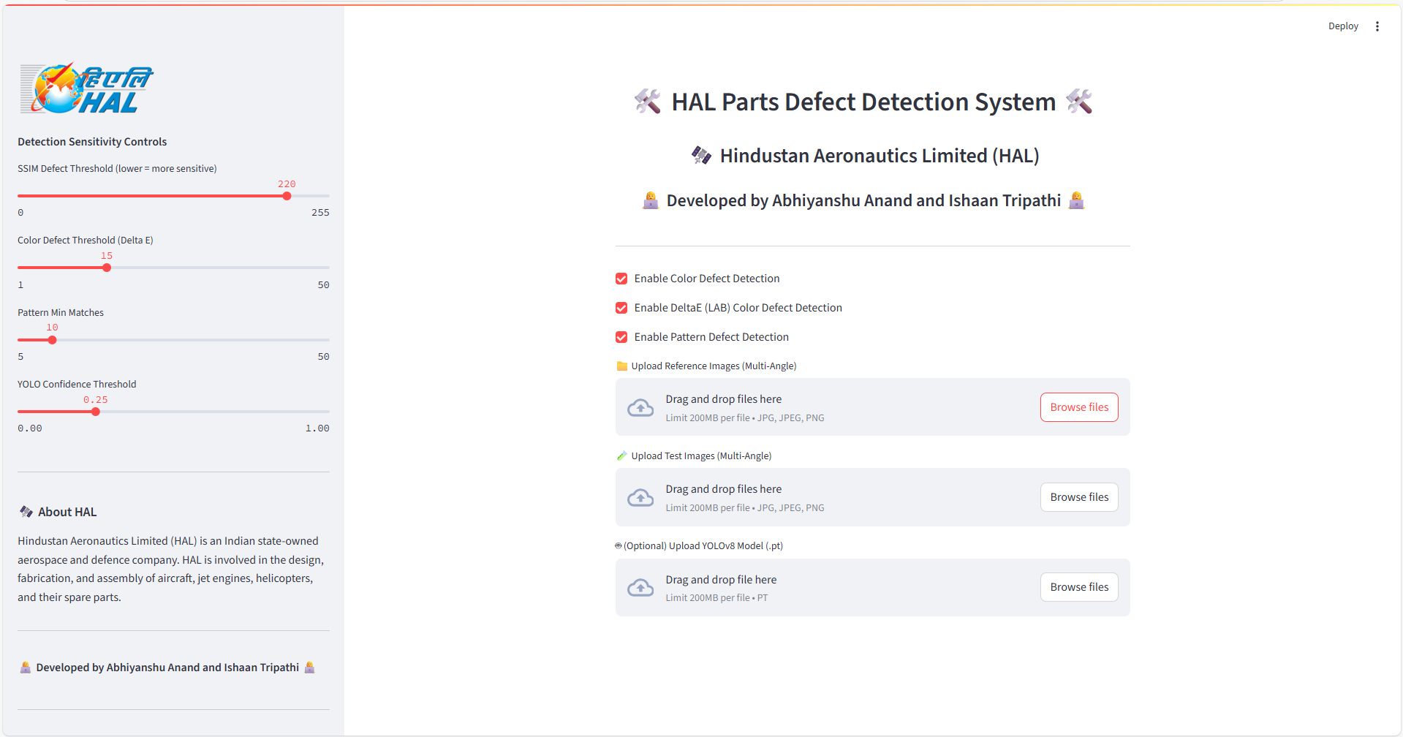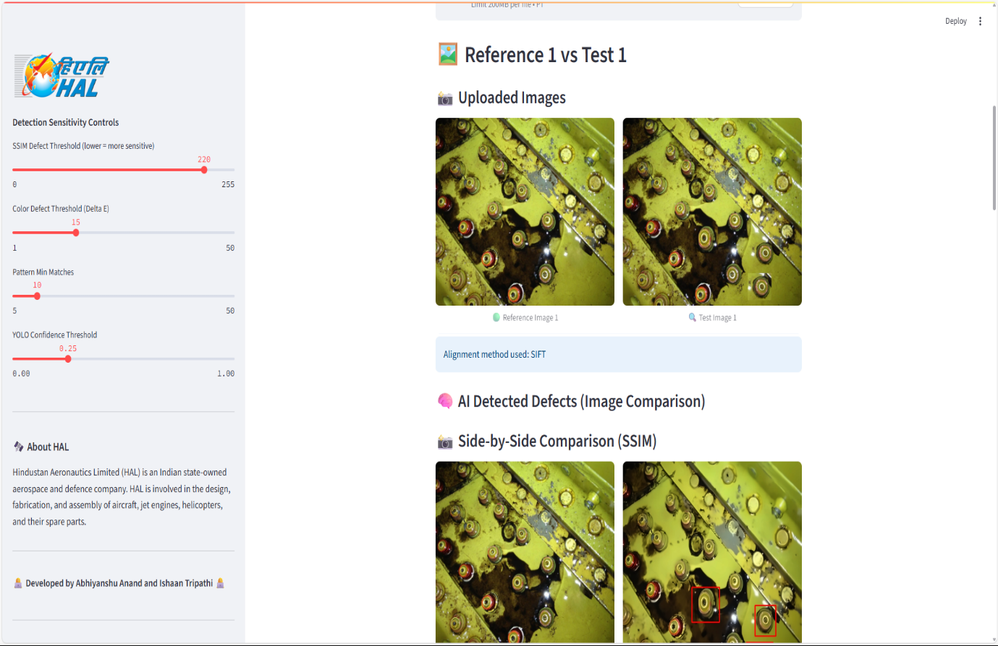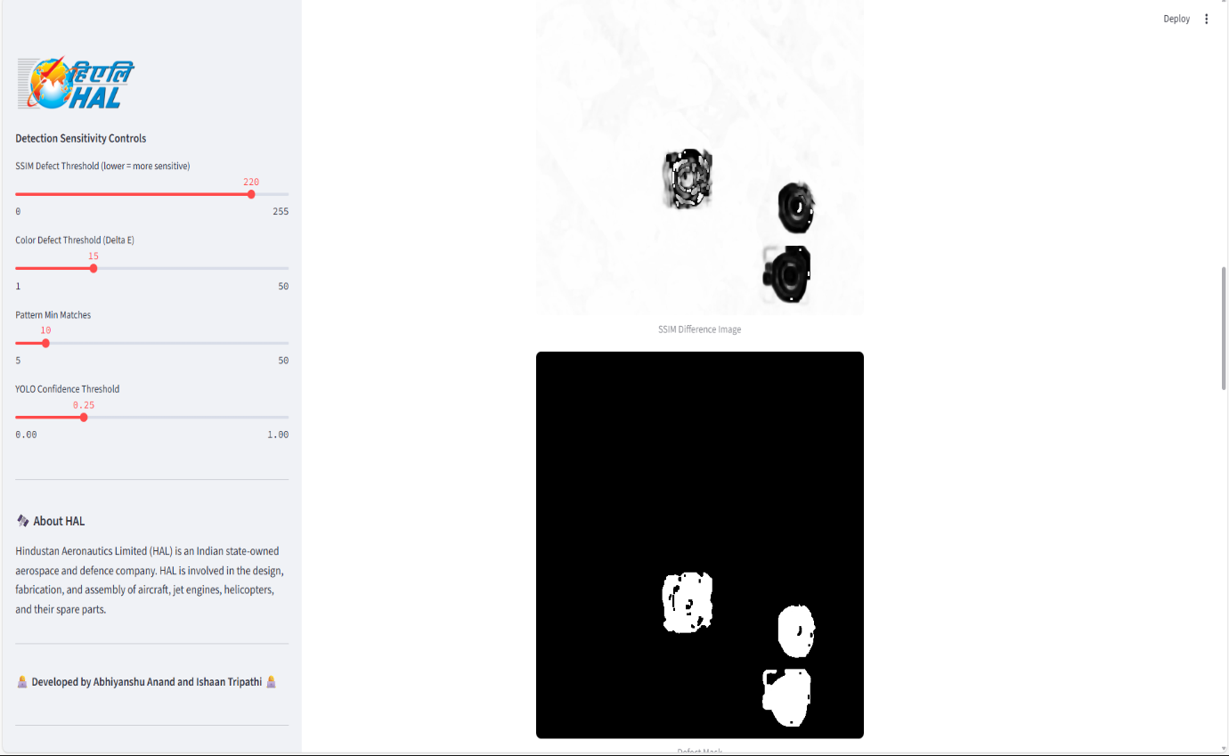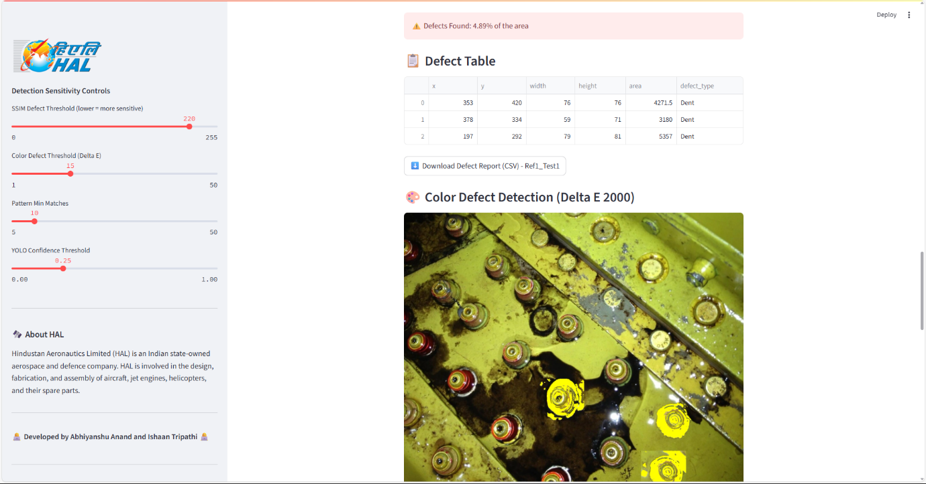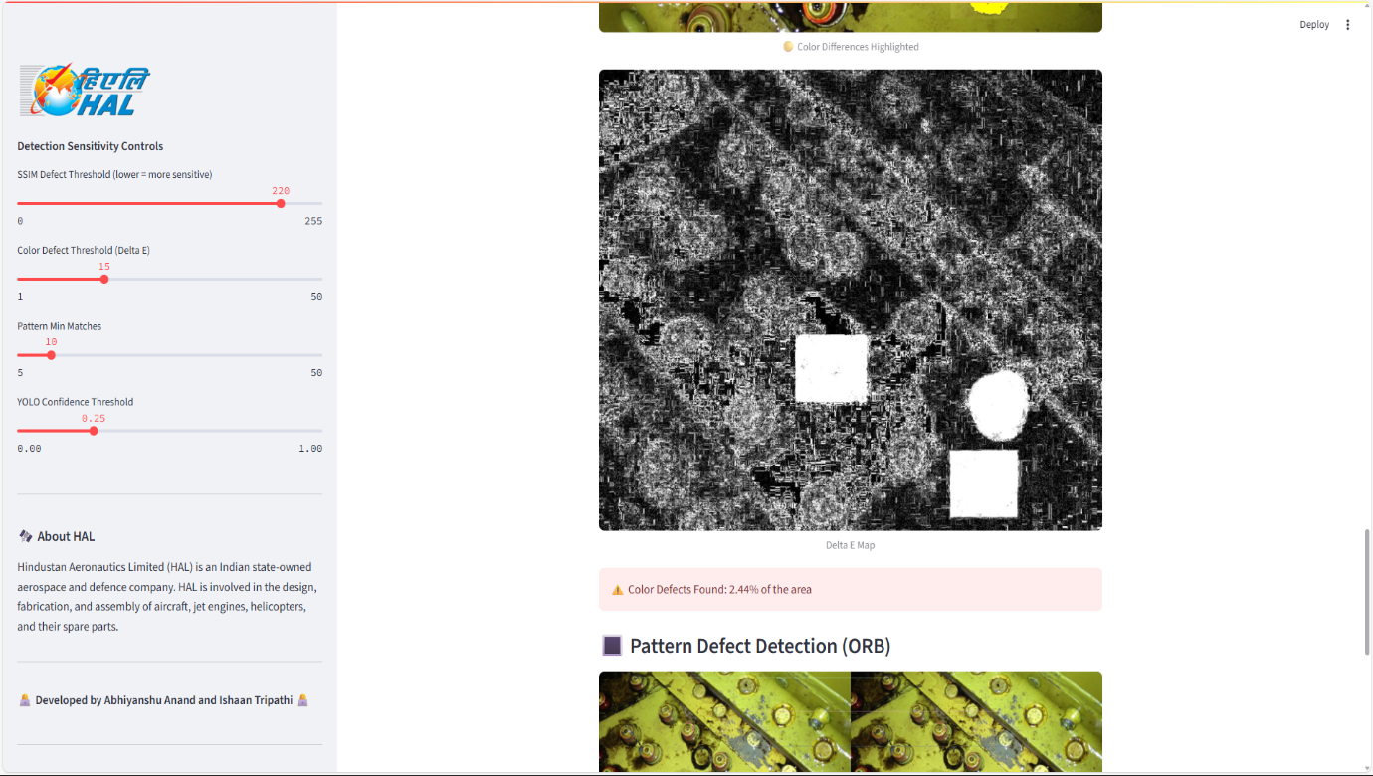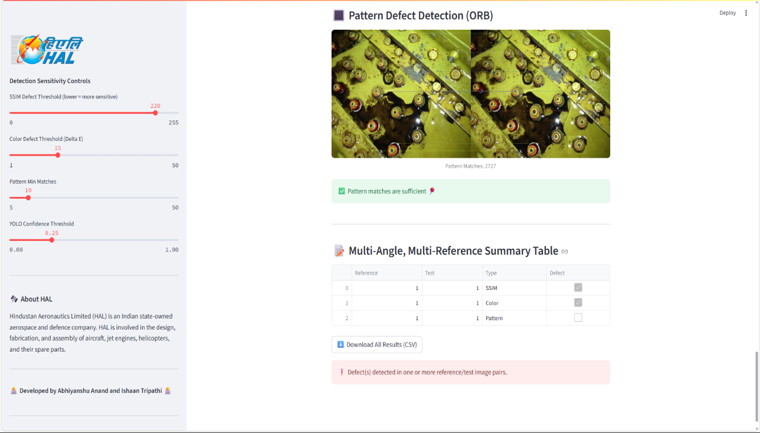

**Fig: Final Dashboard with Analysis**

**Recommendations**

Based on the current implementation and operational insights of the **HAL Parts Defect Detection System**, the following recommendations are proposed to further enhance system performance, user experience, and future scalability:

**1. Enhanced User Training and Documentation**

Provide detailed user manuals, video tutorials, and hands-on training sessions for **Shop Floor Inspectors**, **Quality Control (QC) Users**, and **System Administrators** to ensure smooth system adoption, reduce misinterpretation of defect reports, and encourage consistent usage.

**2. Implement Advanced User Authentication and Security**

Integrate secure authentication mechanisms such as **LDAP** or **OAuth** to enforce role-based access and protect sensitive inspection data, image files, and defect reports from unauthorized access.

**3. Introduce Automated Workflow Notifications**

Develop an automated notification system that sends real-time alerts to users at key process stages (e.g., defect detection completed, QC review required, model updates available) through **email or in-app messaging** to improve communication and reduce processing delays.

**4. Expand Reporting and Analytics Capabilities**

Implement advanced reporting dashboards that provide **analytics on defect trends, detection accuracy, image processing performance, and user activity**. This will enable the QC and management teams to make data-driven decisions and continuously monitor system effectiveness.

**5. Integration with Enterprise Systems**

Plan for future integration with **HAL's ERP and inventory management systems** to link defect detection reports with part procurement, tracking, and maintenance logs, creating a fully connected quality management ecosystem.

**6. Performance Monitoring and Scalability**

Establish system performance monitoring to track processing times, file upload speeds, and concurrent user load. Prepare the infrastructure for **horizontal and vertical scaling** to accommodate increasing image volumes and expanding user groups across shop floors.

**7. Regular Data Backup and Disaster Recovery Plan**

Implement an automated **backup and recovery strategy** to safeguard critical defect analysis records, user reports, and image datasets, ensuring business continuity in the event of system failure or data corruption.

**8. User Feedback Loop and Continuous Improvement**

Set up periodic feedback collection from all user roles to identify pain points and areas for improvement. Regularly update system features, detection models, and user interface components based on real-world user experiences to keep the system evolving and user-centric.

By implementing these recommendations, the **HAL Parts Defect Detection System** can evolve into a **more robust, scalable, and secure platform** that not only meets current operational requirements but also supports HAL’s long-term objectives of precision manufacturing, quality assurance, and digital transformation.

**References**

Below is a list of references and resources that were used during the development, analysis, and documentation of the HAL Parts Defect Detection System project:

### Official Sources

1. Hindustan Aeronautics Limited (HAL) Official Website  
   <https://hal-india.co.in>  
   Used for official information on company background, operations, and objectives.
2. HAL TAD Kanpur Website (Internal Resources)  
   (Accessed via internal network during the project internship)  
   Provided internal documents, inspection workflows, and process guidelines.
3. OpenCV Documentation  
   https://docs.opencv.org  
   Primary reference for image processing techniques, feature detection algorithms, and computer vision workflows.
4. Streamlit Documentation  
   https://docs.streamlit.io  
   Used for building the interactive web interface and deploying the defect detection dashboard.
5. Ultralytics YOLOv8 Documentation  
   https://docs.ultralytics.com  
   Reference for integrating the YOLOv8 object detection model for defect identification.
6. Python Official Documentation  
   <https://docs.python.org/3/>  
   Resource for Python libraries, syntax references, and best practices.
7. MDN Web Docs  
   <https://developer.mozilla.org>  
   Used for understanding HTML, CSS, and JavaScript standards for UI development.
8. Stack Overflow & GitHub  
   Community-driven platforms used extensively to resolve code-level issues and explore image processing best practices.
9. GeeksforGeeks & TutorialsPoint  
   Additional learning resources for Python, OpenCV, and machine learning integration.

### Project-Specific Resources

1. HAL TAD Defect Detection Process Documentation  
   Provided by HAL’s inspection teams for understanding the manual inspection workflow and defect classification standards.
2. Internship Mentorship Notes & Project Guidelines  
   Guidance, feedback, and system requirements provided by HAL IT Department personnel throughout the internship.
3. Sample Image Datasets (Provided by HAL)  
   Reference images and defect samples used for model testing, system validation, and accuracy tuning.